kxb:1 KSE:1 afterload:0.108

TMP 23



TMP 30



kxb:120 KSE:1 afterload:0.108

TMP 23



TMP 30



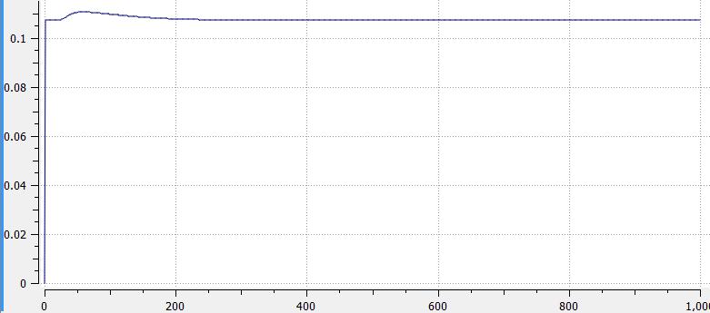

If kxb is 1, active_tension is tiny compared to the passive force…

** In the above figure, Tmp=30, kxb=1, KSE=1, isometric contraction for SL= 2.3

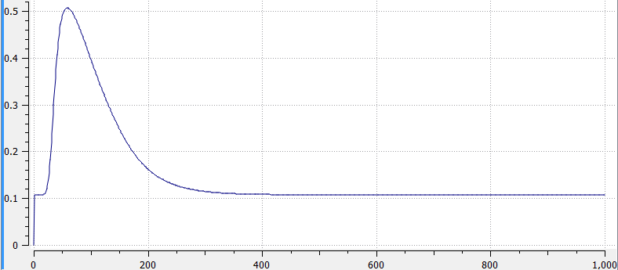

** In this figure, Tmp=30, kxb=120, KSE=1, isometric contraction for SL=2.3



**In the above image Tmp:30, kxb:120, KSE:1, and afterloads: 0.108, 0.2, 0.3, 0.4, 0.5



**In the above image Tmp:30, kxb:1, KSE:1, and afterloads: 0.10720582, 0.10797134, 0.10880342, 0.1096355, 0.11046758.



**Here is a zoomed in image of the previous work-loops

What I think I know so far: when TmpC= 30, the force does weird things, isotonic shortening phase is not flat. When TmpC= 23 there is isolation at the start of the isotonic shortening phase, but the phase is relatively flat. keep kxb = 120… when kxb=1 I get very short, weirdly shaped work-loops. The Next thing I should do it collect data for the test case TmpC23_kxb_120_KSE1. This should give me results very similar to the results I had at the meeting last week.

